Official league roster - BASKETBALL
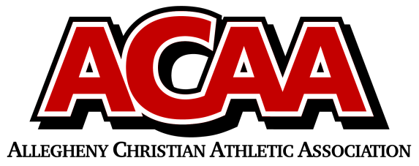
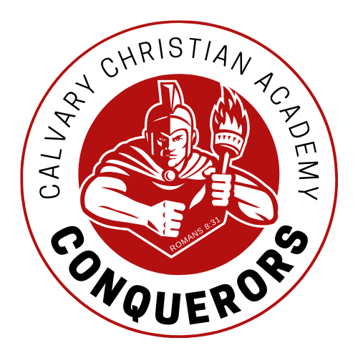
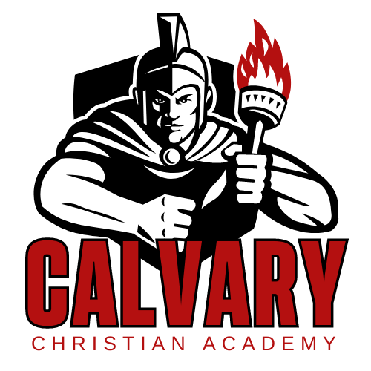

School Name: Calvary Christian Acad.
Team Colors: red/gold/white
Overall Wins ___ Losses ____ Ties ___
ACAA Wins ___ Losses ____ Ties ___ OPPONENT: __________________________
Date: _________
Number | Name | Year | Position | Height | Homeschool
22 | Tyrell Lapp | Sr. | Forward
10 | Paiton Zimmerman | Jr. | Guard
20 | Micah Lloyd | Jr. | Guard
11 | Ben Slusher | Jr. | G/F |  | X
12 | William Lane | Soph. | Forward
14 | Jackson Suttles | 8th | Guard
23 | Jacob Anders | 8th | Guard
13 | Vanner Henney | 8th | Forward
2 | Harvey Anderson | 7th | Guard
55 | Zachary Feaster | 7th | Guard
3 | Clayton Ayers | 7th | Guard
4 | Ezra Lloyd | 7th | Guard |  | X
MGR
 | *Denotes team captain

Head Coach: Hunter rodgers
Asst. Coach: mark ayers
Asst. Coach: charlie marshall
Asst. Coach: Ben Kilian

Official ACAA League Team Roster. to be submitted to the scorer’s table before each game.

